**Inventory Management System (IMS)**

**Master Screens :-**

1. Item Group
2. Item
3. Item Price
4. Price List

**Warehouse :-**

1. Warehouse

**Transaction :-**

1. Stock Entry
2. Stock Transaction Ledger

**Setting :-**

1. Setting

**Reports :-**

1. Stock Entry Report
2. Stock Maintenance Report
3. Stock Transaction Report

**Workflow Diagrams**

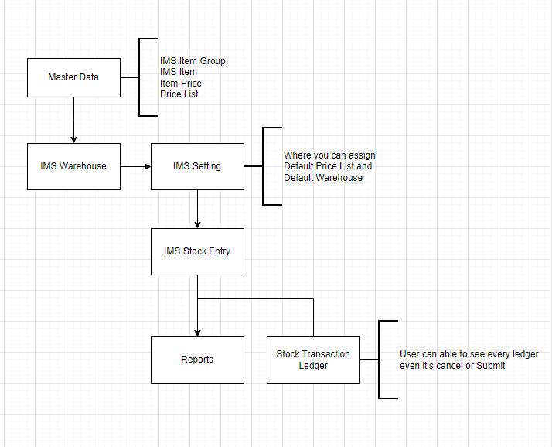

**Dashboard**

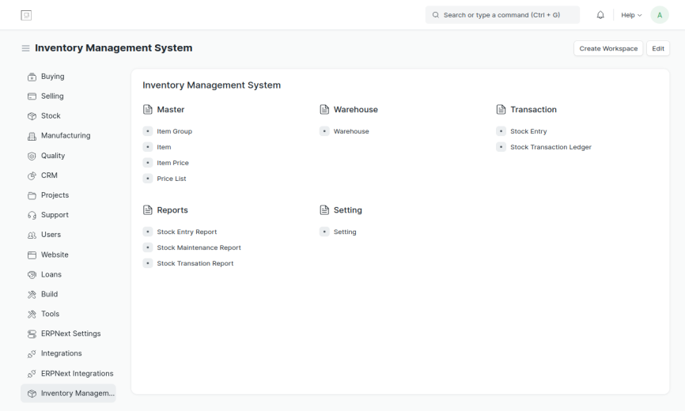

**Workflow :-**

1. Create **Price List** :-
   1. Click on **Price List**
   2. Click on **Create your first IMS Price List** or **+Add IMS Price List**
   3. Write **Price List Name**
   4. **Currency** will automatically be there by default **INR**
   5. Click on **Save**

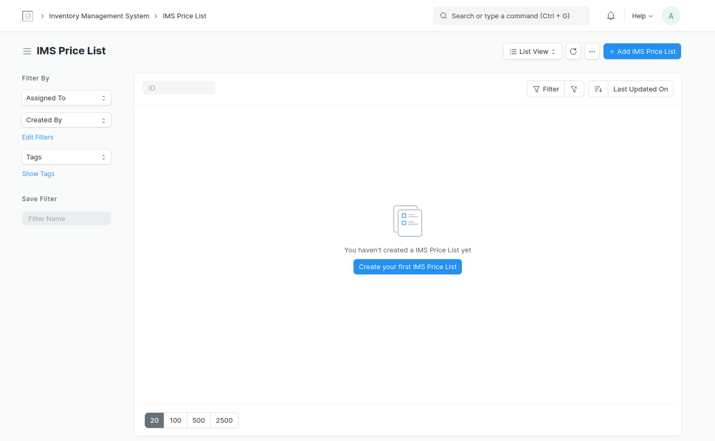

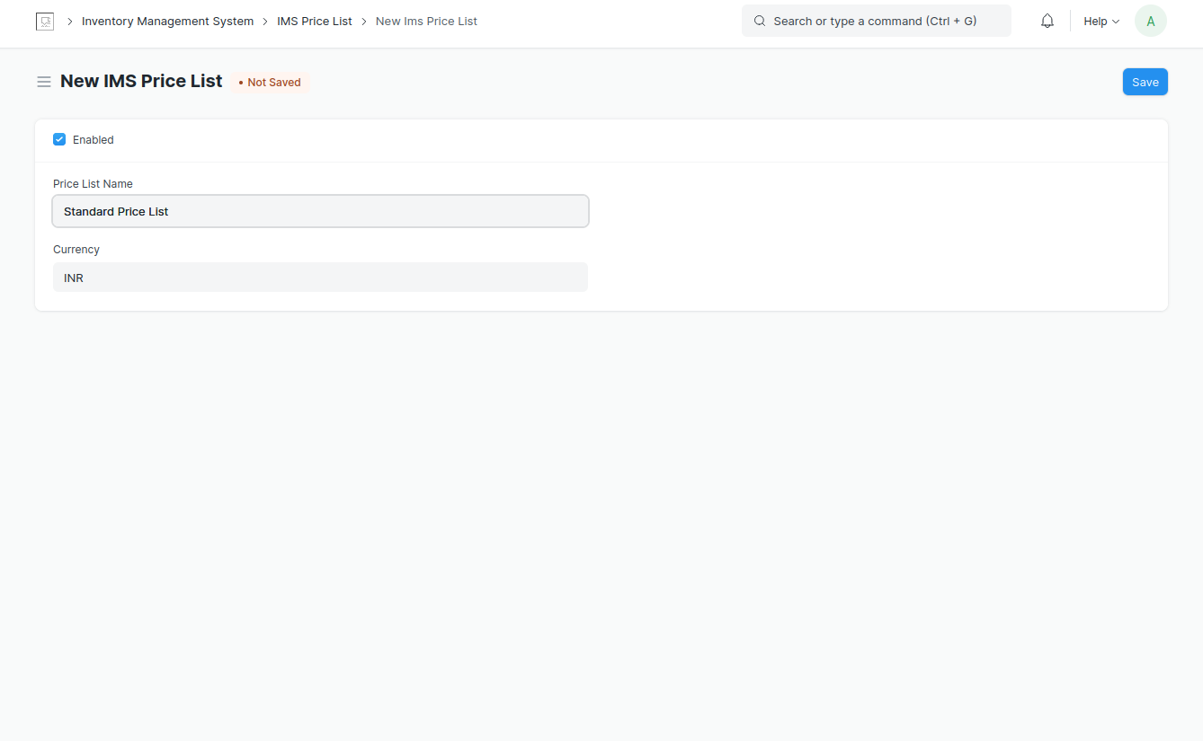

1. Create **Warehouse :-**
   1. Click on **Warehouse**
   2. Click on **+New**
   3. Write **Warehouse Name**
   4. Write **Parent Warehouse** & **Old Parent** (if there)
   5. **Disabled** (to disable) & **Is Group** are two check-boxes (optional)
   6. Click on **Save**

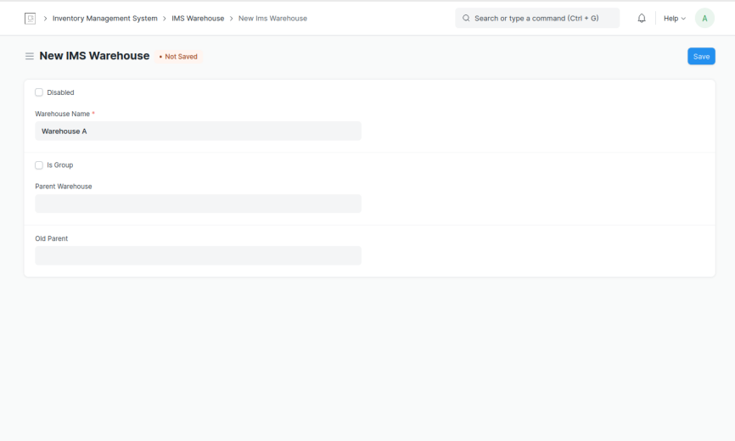

1. Create **Setting :-**
   1. Click on **Setting**
   2. Select **Default Price List**
   3. Select **Default Warehouse**
   4. Click on **Save**

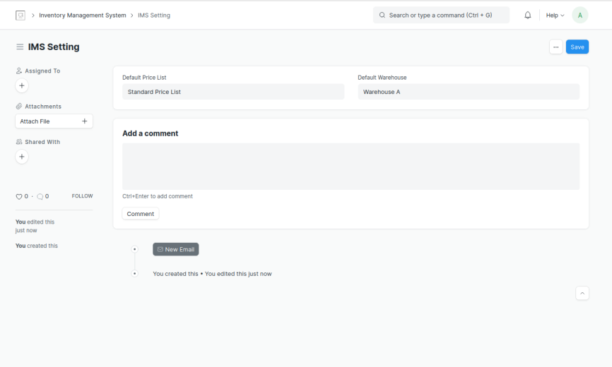

1. Create **Item Group :-**
   1. Click on **Item Group**
   2. Click on **Create your first IMS Item Group** or **+Add IMS Item Group**
   3. Write **Item Group Name**
   4. Write **UOM** {unit of measure}
   5. Click on **Save**

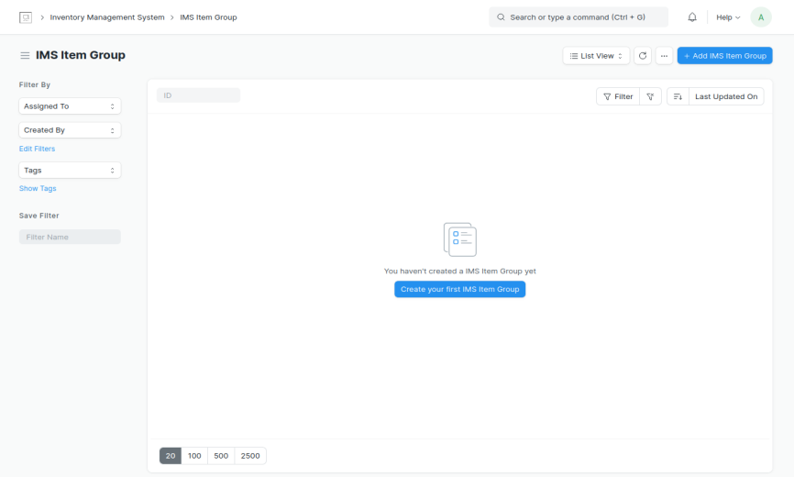

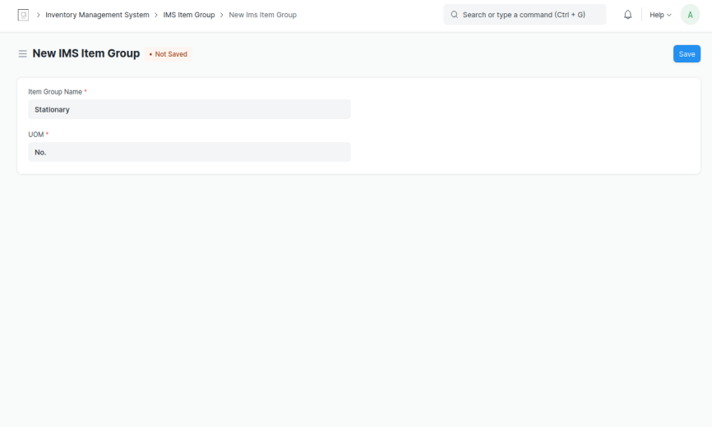

1. Create **Item** :-
   1. Click on **Item**
   2. Click on **Create your first IMS Item** or **+Add IMS Item**
   3. Write **Item Name**
   4. Select **Item Group**
   5. **Item Code** and **UOM** will automatically be fetched.
   6. Enter **Opening Stock**
   7. Enter **Valuation Rate**
   8. Enter **Standard Rate**
   9. Write **Description**
   10. Click on **Save**

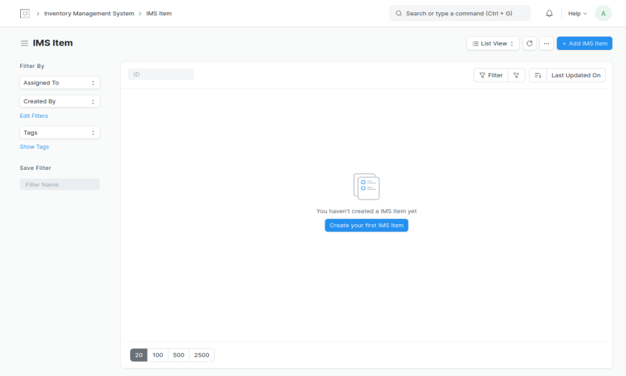

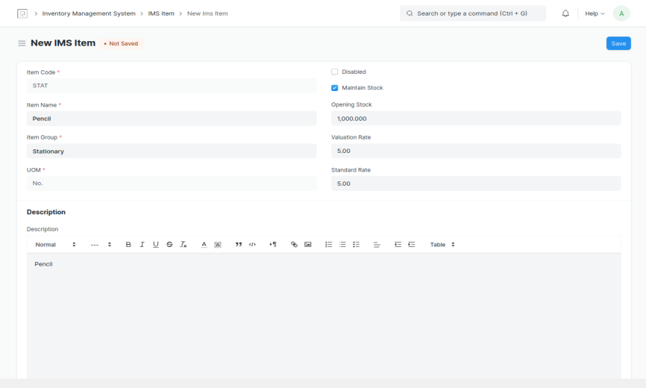

**Note :-** Here **Item Price,** **Stock Entry & Stock Entry Ledger** screens will automatically be created. (**Valid From** (Date) & **Valid Upto** (Date) is set today’s date and date after 1 month respectively.)

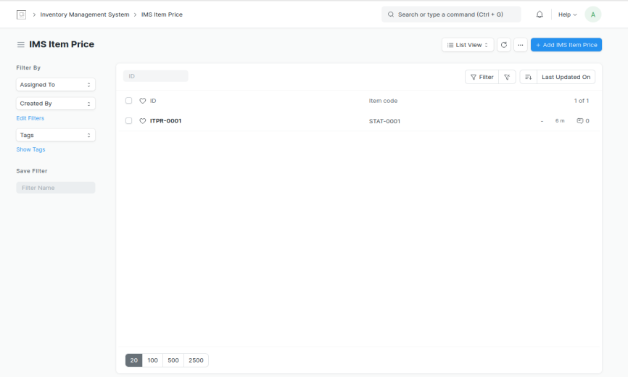

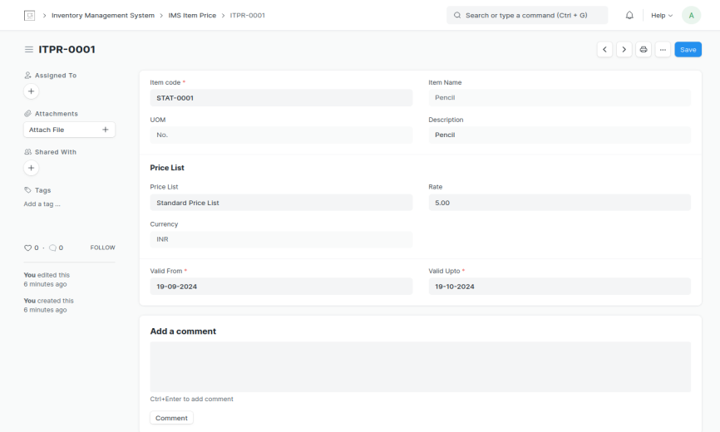

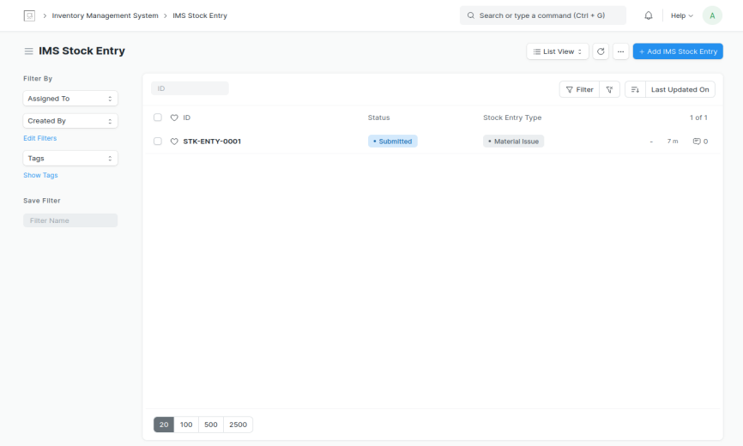

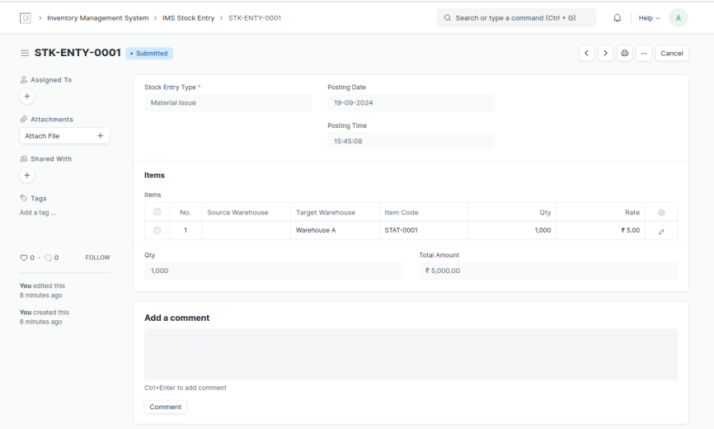

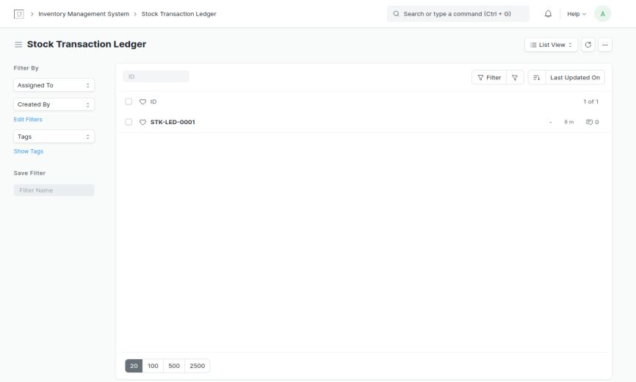

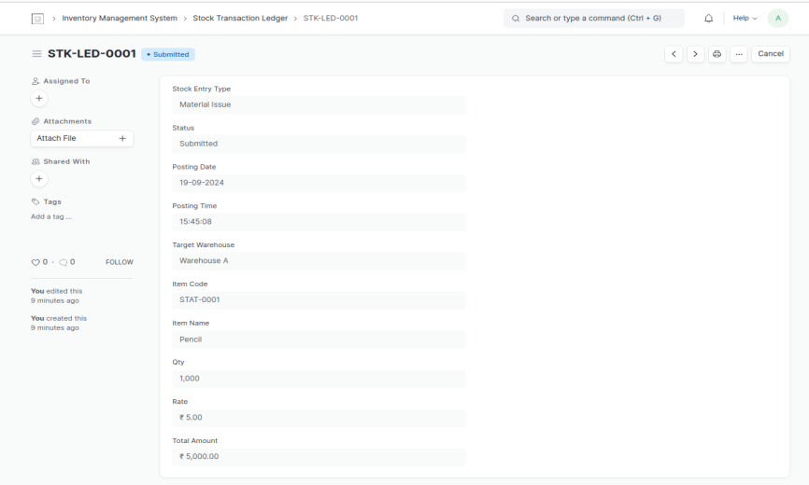

**Note :-** Item Price & Stock Entry also can be created manually as per requirement.

1. **Create Item Price** :-
   1. Click on **Item Price**
   2. Click on **Create your first IMS Item Price** or **+Add IMS Item Price**
   3. Select **Item Code** (**Item Name, UOM, Description** will be fetched accordingly).
   4. Select **Price List** (**Currency** will be fetched accordingly).
   5. Enter **Rate**
   6. Enter **Valid From** (Date) & **Valid Upto** (Date)
   7. Click on **Save**

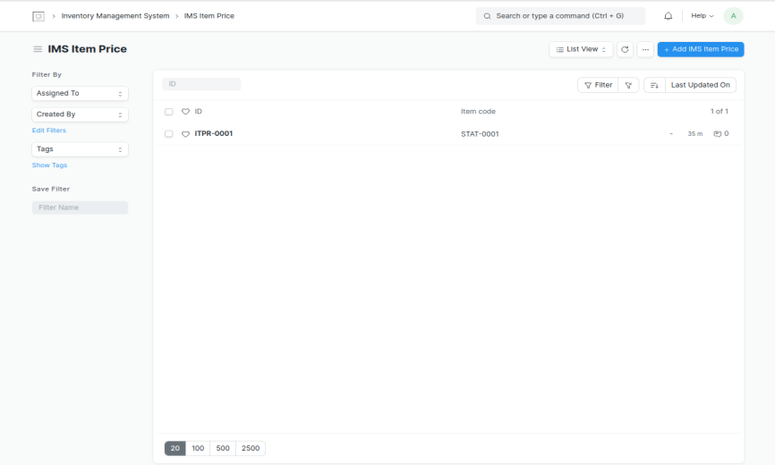

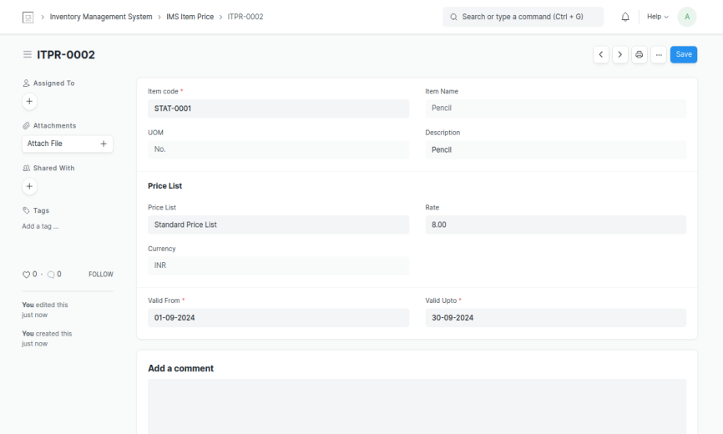

1. **Create Stock Entry** :-
   1. Click on **Stock Entry**
   2. Click on **Create your first IMS Stock Entry** or **+Add IMS Stock Entry**
   3. Select **Stock Entry Type [ Material Issue | Material Transfer ]**
   4. **Posting Date** will automatically be there. **Edit Posting Date & Time** check box is there if **Posting Date** needs to be changed. Once Checked it allows to change **Posting Date**.
   5. **In Items** table Select **Source Warehouse, Target Warehouse** & **Item Code** (**Item Name, Item Group, Description, UOM** and **Price Rate** (changeable)will be fetched automatically)
   6. Enter **Qty** (**Total Amount** will be calculated accordingly).
   7. Click on **Save** & **Submit**.

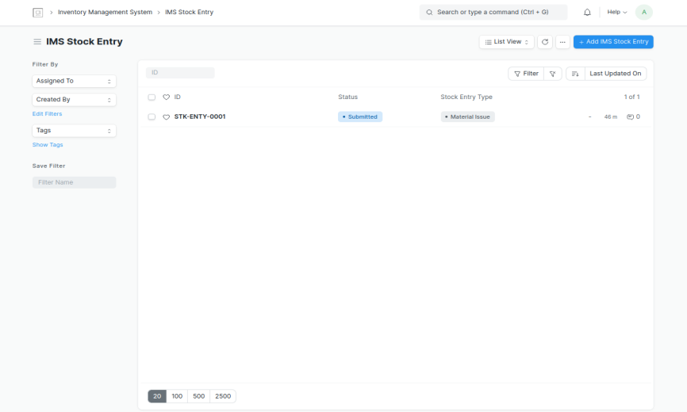

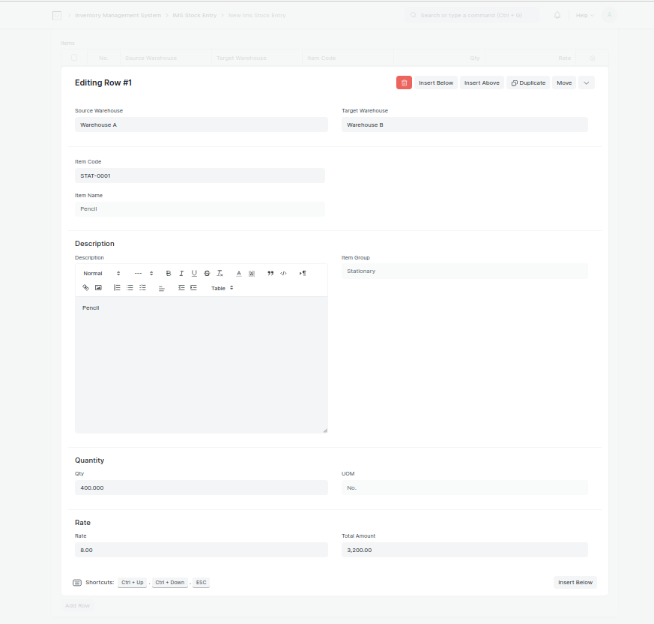

**Note :- Stock Entry** will update **Stock Level** table in **Item** Screen according to **Material Issue** in one **Warehouse** and **Material Transfer** from one **Warehouse** to another **Warehouse**.

**Reports :-**

1. **Stock Entry Report**

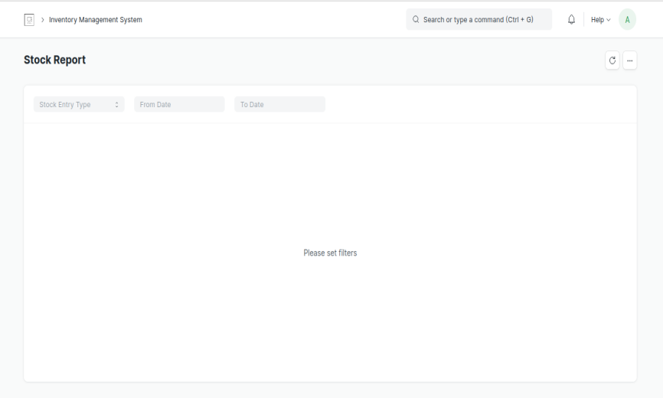

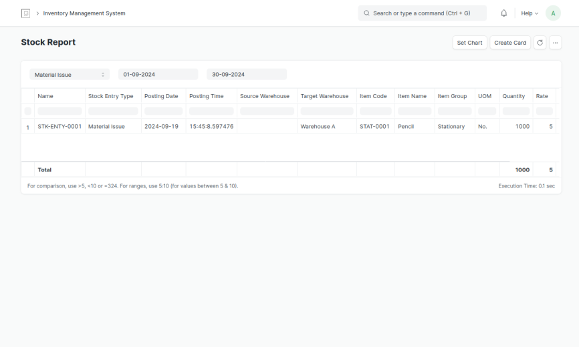

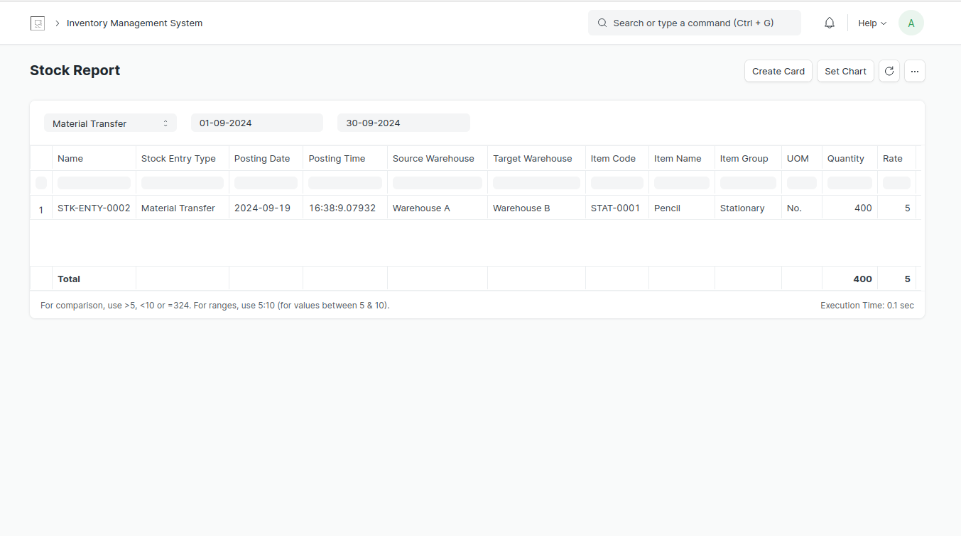

1. **Stock Maintenance Report**

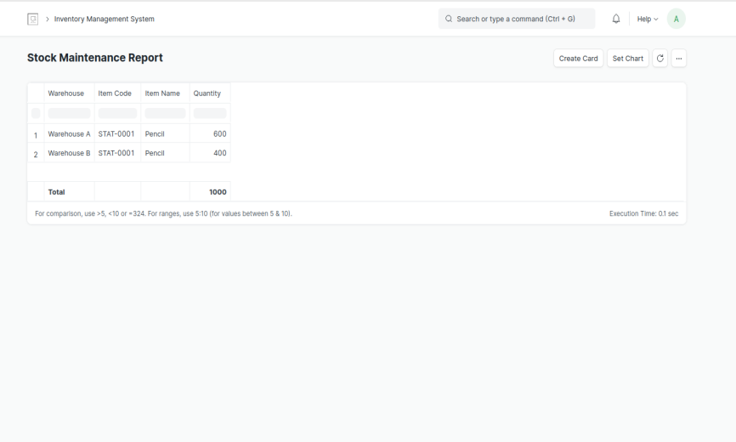

1. **Stock Transaction Report**

